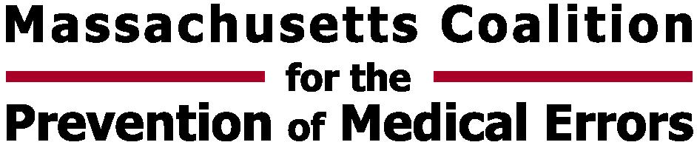
 | 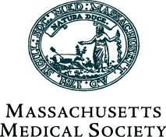
Preventing MRSA: A Sharing and Networking Session
July 30, 2007
Registration & Networking 7:15 a.m. – 8:15 a.m.
Program 8:15 a.m. - 12:45 p.m.
Massachusetts Medical Society, Waltham Woods Conference Center, Waltham, MA
The Massachusetts Coalition for the Prevention of Medical Errors with the Massachusetts Hospital Association, the Massachusetts Medical Society and Masspro, is hosting a sharing and learning session on preventing Methicillin-resistant Staphylococcus aureus (MRSA) infections.
The goal of this program is to facilitate sharing among hospital participants of lessons learned and successful strategies for implementing MRSA infection control programs in the acute care hospital setting.

Participants will discuss approaches that have identified populations at risk, helped promote consistent, effective hand hygiene, environmental cleaning and disinfection, and contact precautions, as well as various strategies for active surveillance. Come prepared to share your organization's strategies for reducing MRSA or other hospital-acquired infections.

PARTICIPANTS:
We are seeking one to two individuals from each acute care hospital in Massachusetts who would be, or currently are, organizing efforts to prevent hospital-acquired infections to participate in this event. Participants may be clinical leaders or from quality improvement or infection control.
NURSING CREDITS:
This program is in compliance with the Massachusetts Board of Registration in Nursing Continuing Education Regulation at 244 CMR 5.00 for 4.6 contact hours.

REGISTRATION:
Register Online through www.macoalition.org
Registration Fee = $60 per person (Visa, Mastercard, or Check accepted)

LEARNING OBJECTIVES
Participants will:
❑ Learn strategies that have helped promote consistent, effective hand hygiene, environmental cleaning and disinfection, and use of contact precautions;
❑ Learn approaches that have identified populations at risk for MRSA infection;
❑ Learn successful strategies for active surveillance;
❑ Learn recommended strategies to meet the MRSA goal in the 5 Million Lives Campaign.

